Conditions of Admission
 Be a high school graduate under the age of 30 when applying for the undergraduate programs;
 Be a bachelor’s degree holder under the age of 35 when applying for the master’s programs;

＊The Bachelor Degree programs are taught in Chinese language. Candidates shall have adequate Chinese proficiency.
Applicants of programs of science, engineering, economics, law, management, education instructed in the Chinese language must attain a score of 180 on the HSK4 (Chinese Proficiency Test Level Four); applicants of programs of literature, history and philosophy or the programs of master degree instructed in the Chinese language must attain a score of 180 on the HSK5. A Chinese training course is available at Jiangxi Science and Technology Normal University.

Documents for Application
①Submit Application Form online; (Attached application form)
②Photocopy of Passport (the Page with picture);
③ Highest diploma（Photocopy）;
Prospective diploma recipients must submit official document issued by your current school to prove your current student status or expected graduation date;
④ Academic transcripts. Applicants of Science or Engineering Programs must provide exam result of Math, Physics and Chemistry, applicants of Economics or Management Programs must provide exam result of Math;
⑤ A Study Plan or Research Proposal; This should be a minimum of 200 words for undergraduate students, 500 words for non-degree students, and 800 words for graduate students.
⑥ Digital photo with white background, size of visa picture;
⑦ Self-funding applicants must submit a legal proof of financial support;
⑧ Valid documents of your legal guardians in China;
⑨ The copy of HSK Certificate （If available）;
⑩ Applicants registered in or admitted by other schools shall submit a Release Letter issued by the relevant schools.

Deadline for Application
The Spring Semester starts in February or March and ends in June; the Autumn Semester starts in September and ends in January of the coming year.
Applications for spring semester are only eligible for language students, and all documents must be submitted by November 30.
To apply for the autumn semester, all documents must be submitted by April 30.

Fees

Chinese training course | Bachelor’s programs
12000RMB/Year  Exchange students: Tuition is Free | 14000RMB/Year
Master’s Programs | Other Fees
20000RMB/Year | Registration fee: 500 RMB/Person  Accommodation:  Bedroom:2000RMB/Year  Residence Permit: 800 RMB/Year  Health Verification: 500 RMB/Year  Insurance: 800 RMB/Year  Textbooks: ≈1500 RMB/Year

Every single program in Chinese is open to international students. Every applicant is allowed to apply for only one of those programs. In principle, applicants are not permitted to change their majors after being admitted. However, they can apply to graduate in advance or extend their study period base on the conditions of their studies

List of Bachelor Degree Programs （4years）
77 Undergraduate Program
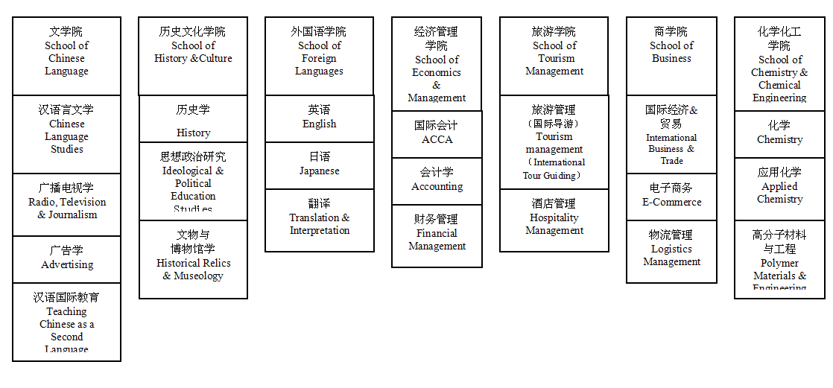
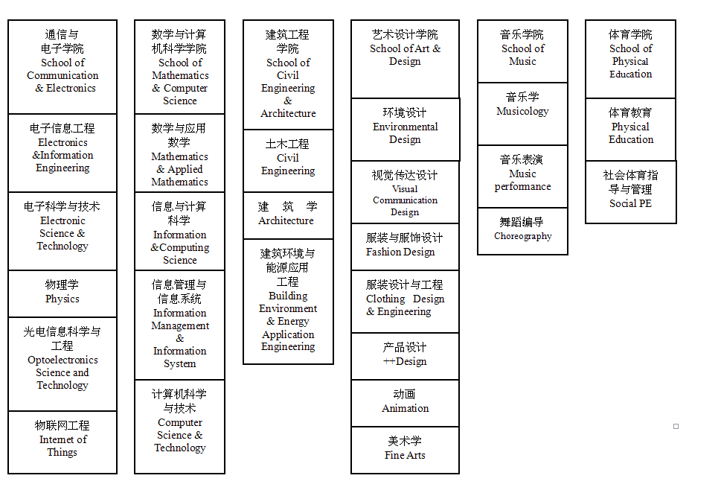
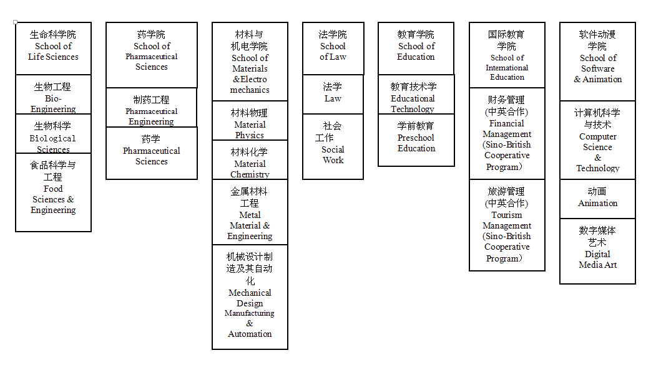
List of Master Degree Programs

Program Name | Level | Years
Theory of Education | Master | 3
Education | Master | 2
Electronic Science and Technology | Master | 3
Design | Master | 3
Chinese Language and Literature | Master | 3
Material Science and Engineering | Master | 3
Business Administration | Master | 3
Musicology and Dancology | Master | 3
Fine Arts | Master | 3
Chemistry | Master | 3
Tourism Management | Master | 2
Arts | Master | 2

